Customer Shopping Behavior Analysis

Project Overview
This project analyzes customer shopping behavior using transactional data from 3,900 purchases across various product categories. The goal is to uncover insights into spending patterns, customer segments, product preferences, and subscriptions behavior to formulate recommendations on business strategies guiding strategies on marketing and budgeting efforts.

Dataset Summary
- Rows: 3,900
- Columns: 18
- Key features
  - Customer demographic (Age, Gender, Location, Subscription Status)
  - Purchase details (Item Purchased, Category, Purchase Amount, Season, Size, Color)
  - Shopping Behavior (Discount Applied, Promo code used, Previous Purchases, Frequency of purchases, Review Rating, Shipping Type)
- Missing Data: 37 values in Review Rating column

Exploratory Data Analysis using Python
The project started with data preparation and cleaning in python
- Data loading: Imported the dataset using pandas
- Initial Exploration: Used df.info() to check structure and .describe() for summary statistics
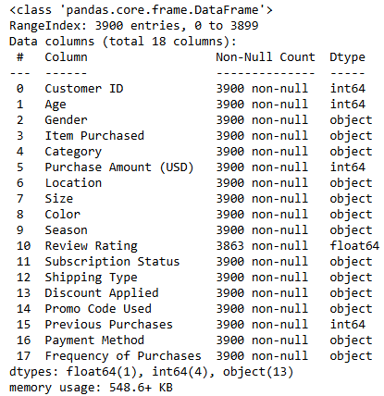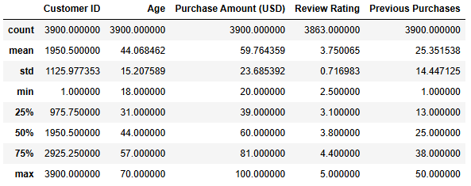
- Missing Data Handling: Checked for null values and imputed missing values in the Review Rating column using the median rating of each product category.
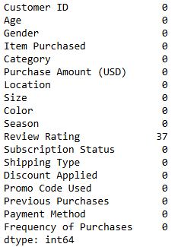> 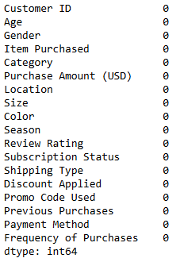
- Column Standardization: Renamed columns to snake case for better readability and documentation
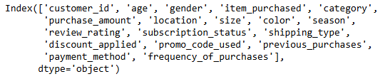
- Feature Engineering:
  - Created age_group column by binning customer ages. (Young Adult, Adult, Middle Aged, Senior)
  - 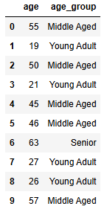
  - Created purchase_frequency_days column from purchase data
  - 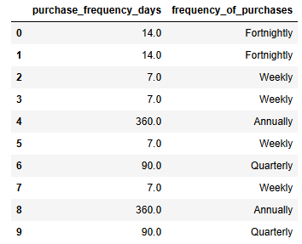
- Data Consistency Check: Verified if discount_applied and promo_code_used were redundant. Dropped promo_code_used.
- Database Integration: Connected Python script to PostgreSQL and loaded the cleaned DataFrame into the database for SQL analysis.

Data Analysis using SQL
Performed structured analysis in PostgreSQL to answer key business questions
- What is the total revenue generated by male vs. female customers?
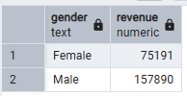
Revenue by Gender – Compared total revenue generated
- Which customers used a discount but still spent more than the average purchase amount?
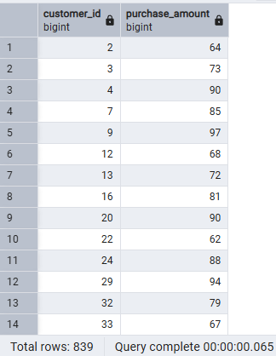
High-Spending Discount Users – Identified list of customers who used discounts but still spent above average purchase amount.
- Which are the top 10 products with the highest average review rating?
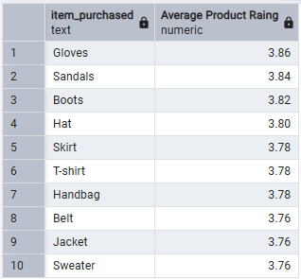
Top 10 Products by Rating – Identified products with highest average review ratings
- Compare the average Purchase Amounts between Standard and Express Shipping.
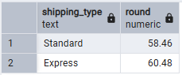
Shipping Type comparison – Compared average purchase amounts between standard and express shipping.

- Do subscribed customers spend more? Compare average spend and total revenue between subscribers and non-subscribers.
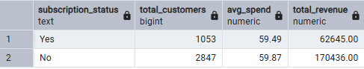
Subscription Status comparison – Compared average purchase amount and total revenue between subscription status.
- Which 5 products have the highest percentage of purchases with discounts applied?
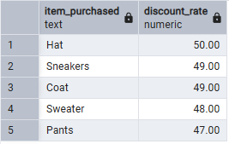
Items that relied heavily on discounts
- Segment customers into New, Returning, and Loyal based on their total number of previous purchases, and show the count of each segment.
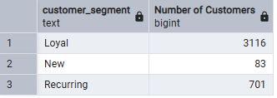
Segmented customers based on purchase frequency rule; New: 1, recurring: 2 to 10, Loyal: >10
  - Refine the segmentation rules to include Recency (purchase_frequency_days) with the frequency (previous_purchases), and show the customer count of each segment.
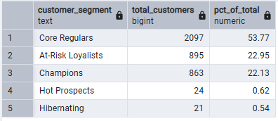
Customer Segmentation combination of Recency and Frequency – breakdown of total customers and percentage of customers in each segment.

  - Which segments drive recurring revenue? Breakdown the counts and subscription rates (Subscription Status = 'Yes') across our customer segments.
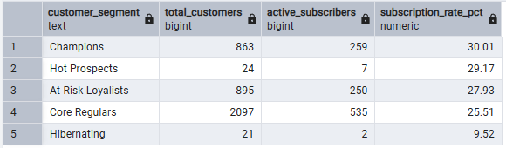
- What are the top 3 most purchased products within each category?
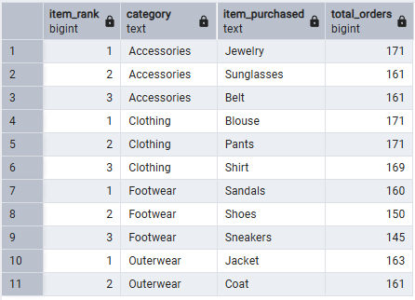
Top 3 products in each category by highest orders
- Are customers who are repeat buyers (more than 5 previous purchases) also likely to subscribe?
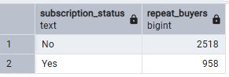
Repeated buyers and their subscription status - repeat buyers defined as > 5
- What is the revenue contribution of each age group?
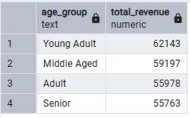
Revenue by age group – Young adult is most important age group for contributing most revenue.

- Which payment method is associated with the highest purchase amount?
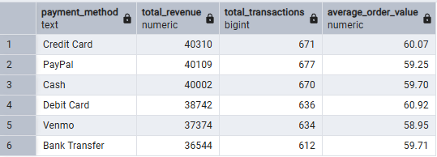
Payment methods - comparing total revenue paid by various payment methods

Dashboard in Power BI
Finally, an interactive dashboard built in Power BI to present insights visually.
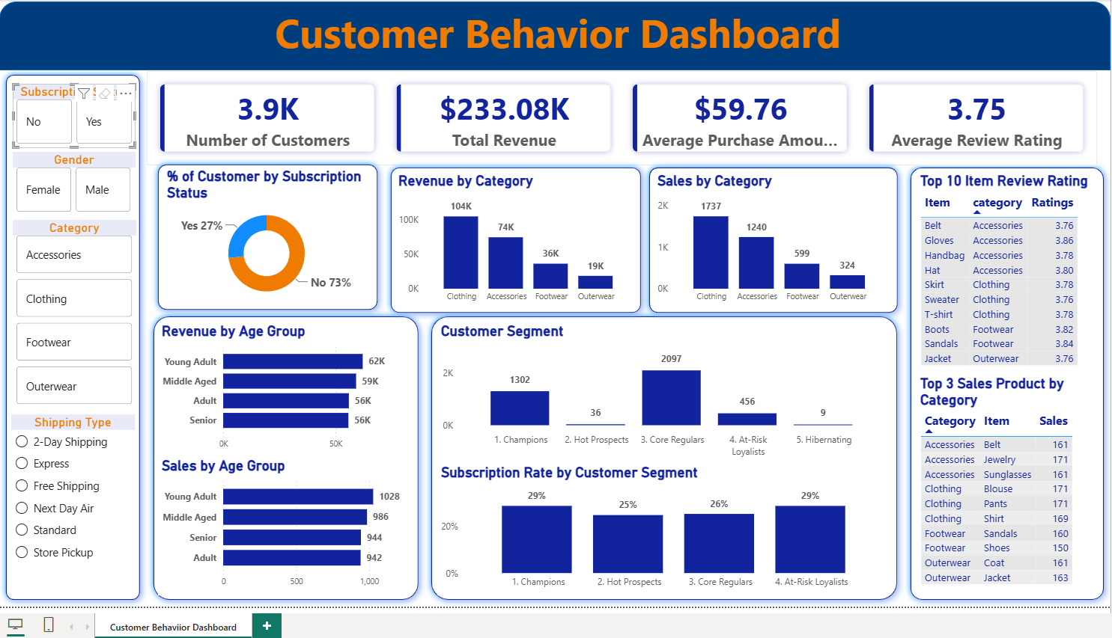

Business Recommendations
Based on the studied analysis, business recommendations are established based on the insights gathered.
- Boost Subscription: Promote exclusive benefits for subscribers. Increase the loyalty program benefits to entice non-subscribers to convert to loyal subscribers.
- Customer Loyalty Program: Reward repeat buyers to move them into “Loyal” customer segment. Create engagement through games to retain “core regulars”.
- Review Discount Policy: Balance sales boosts with margin control. Curate budget catered for various customer segmentation for efficient spending.
- Product Positioning: Highlight top-rated and best-selling products in campaigns. Build customer trust with and TOMA with call-to-action tiles in platform.
- Target Marketing: Focus efforts on high -revenue age groups and express shipping users.
- Partnerships: Partner up and collaborate with credit card payment brands to offer diverse payment plans, rewards, and discounts.

